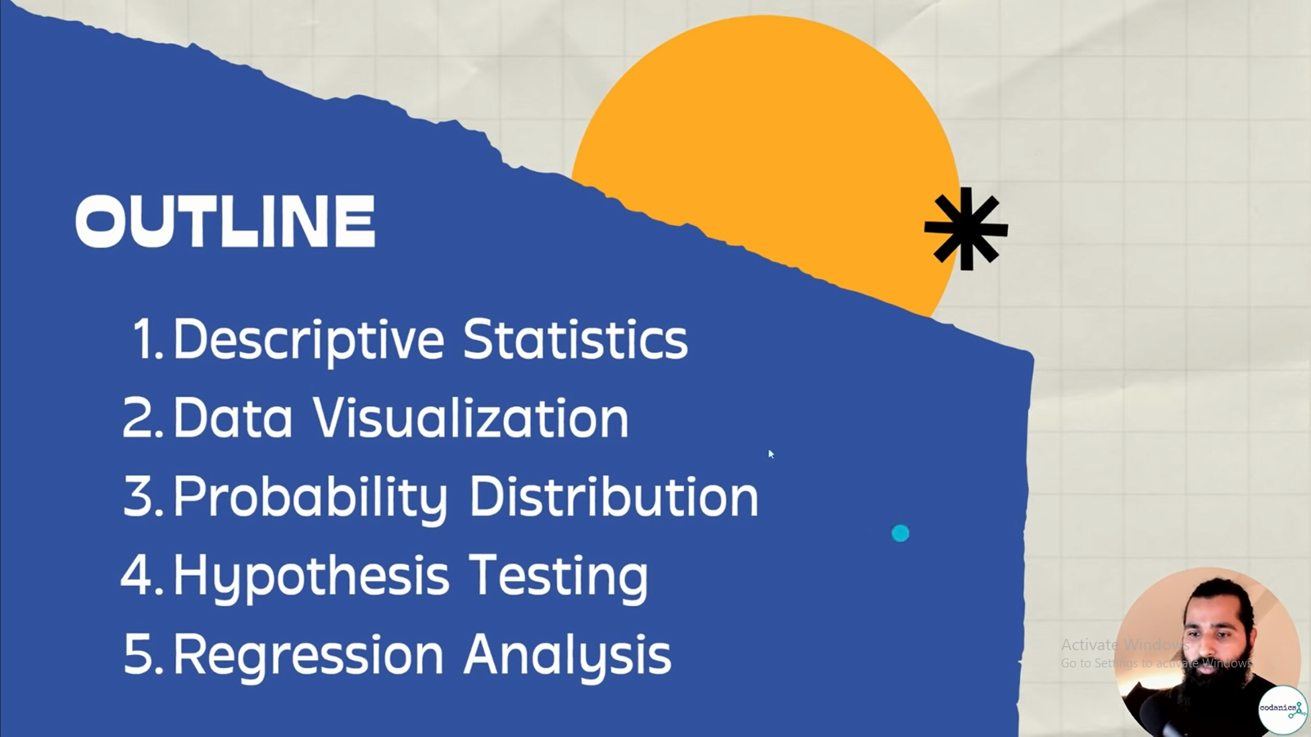



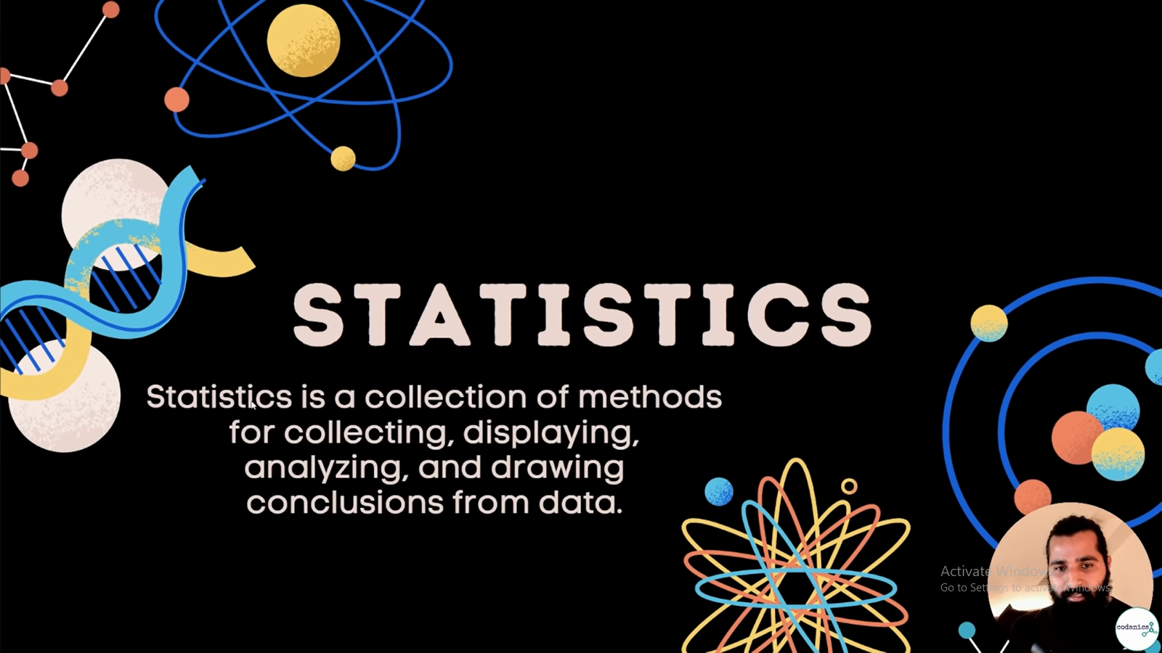



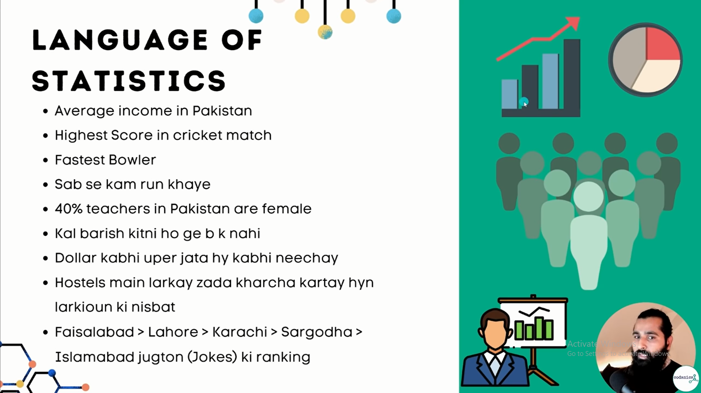

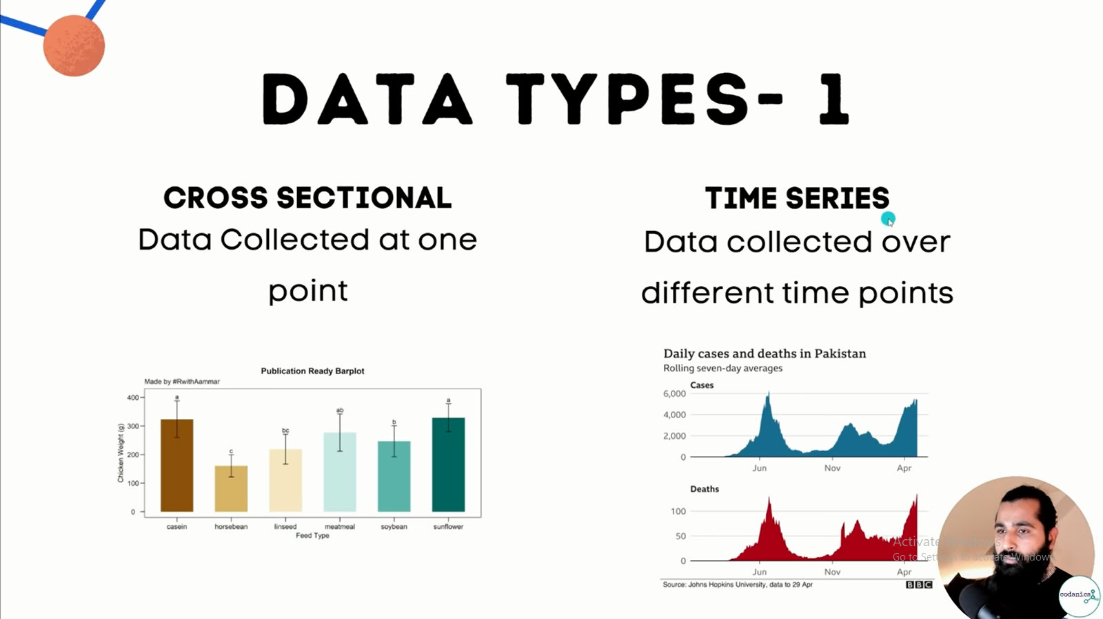

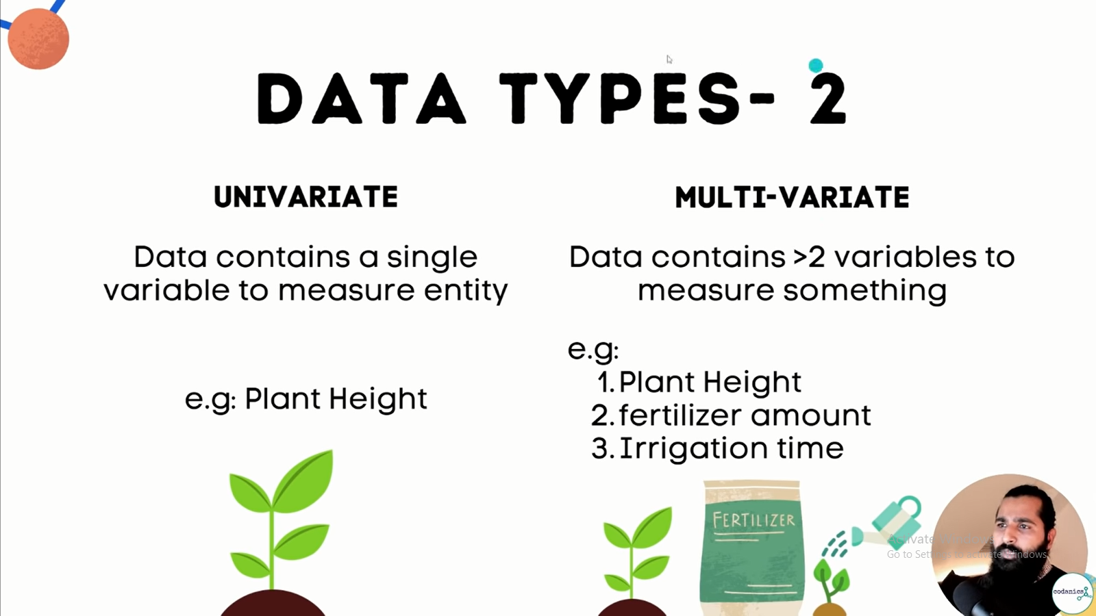

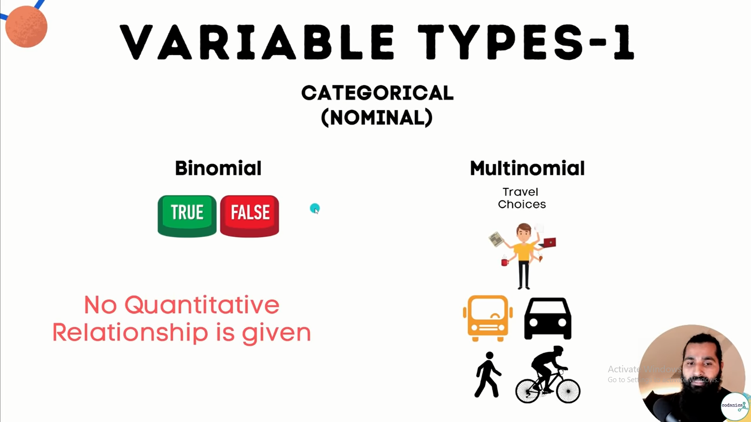

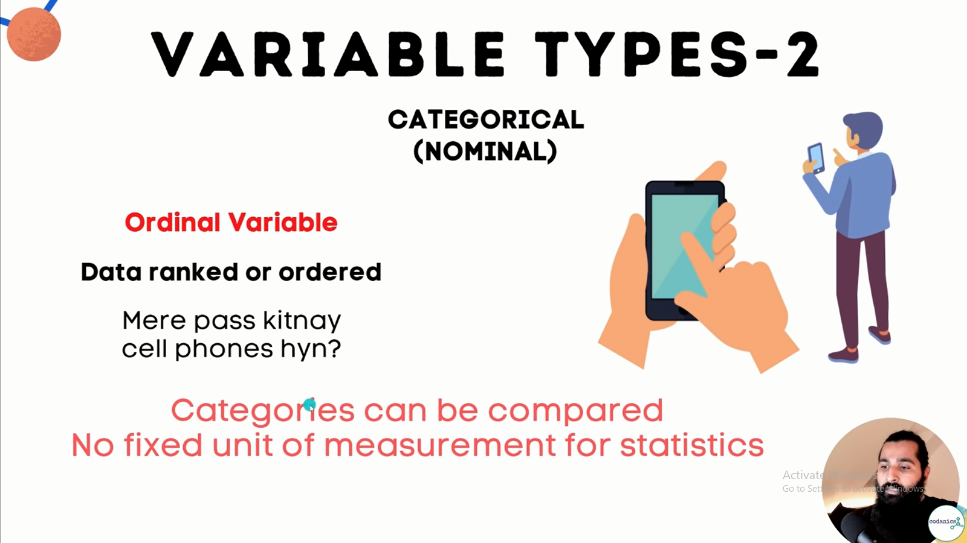

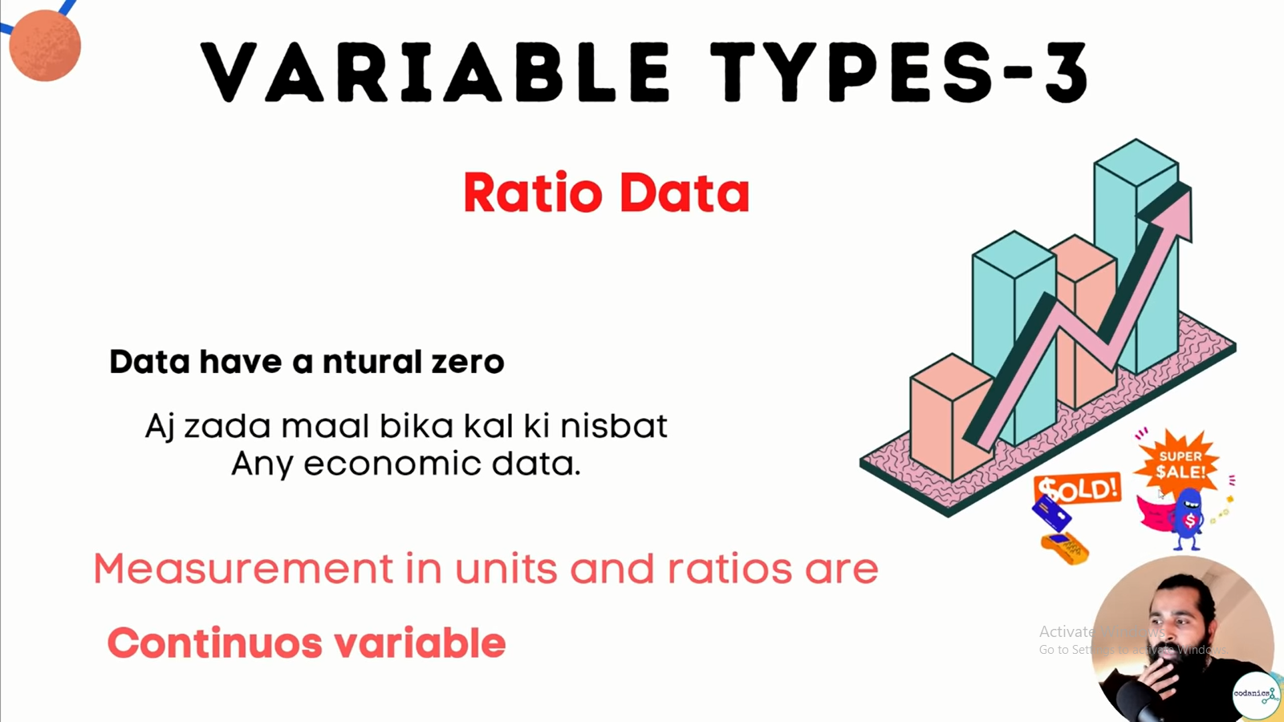

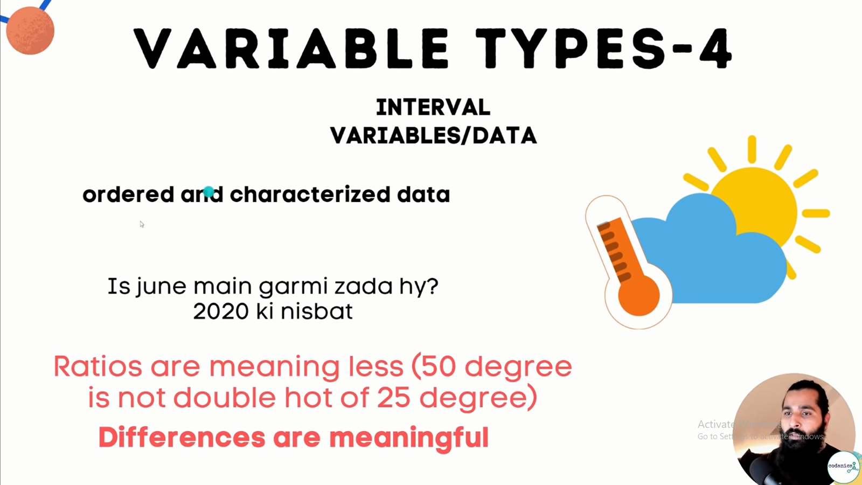



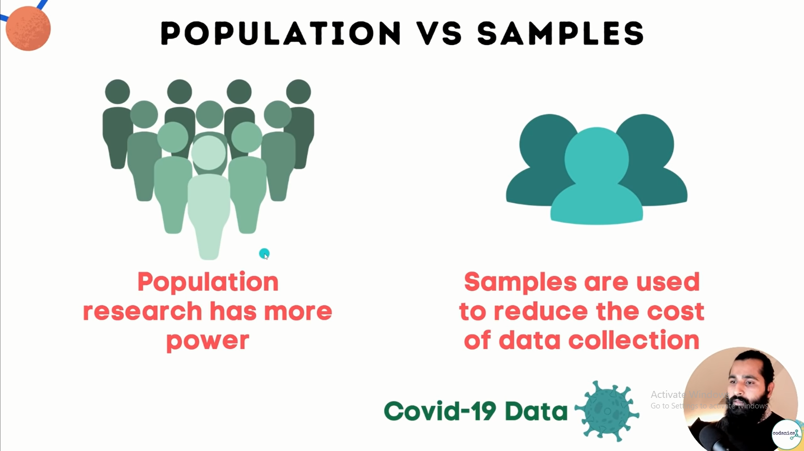

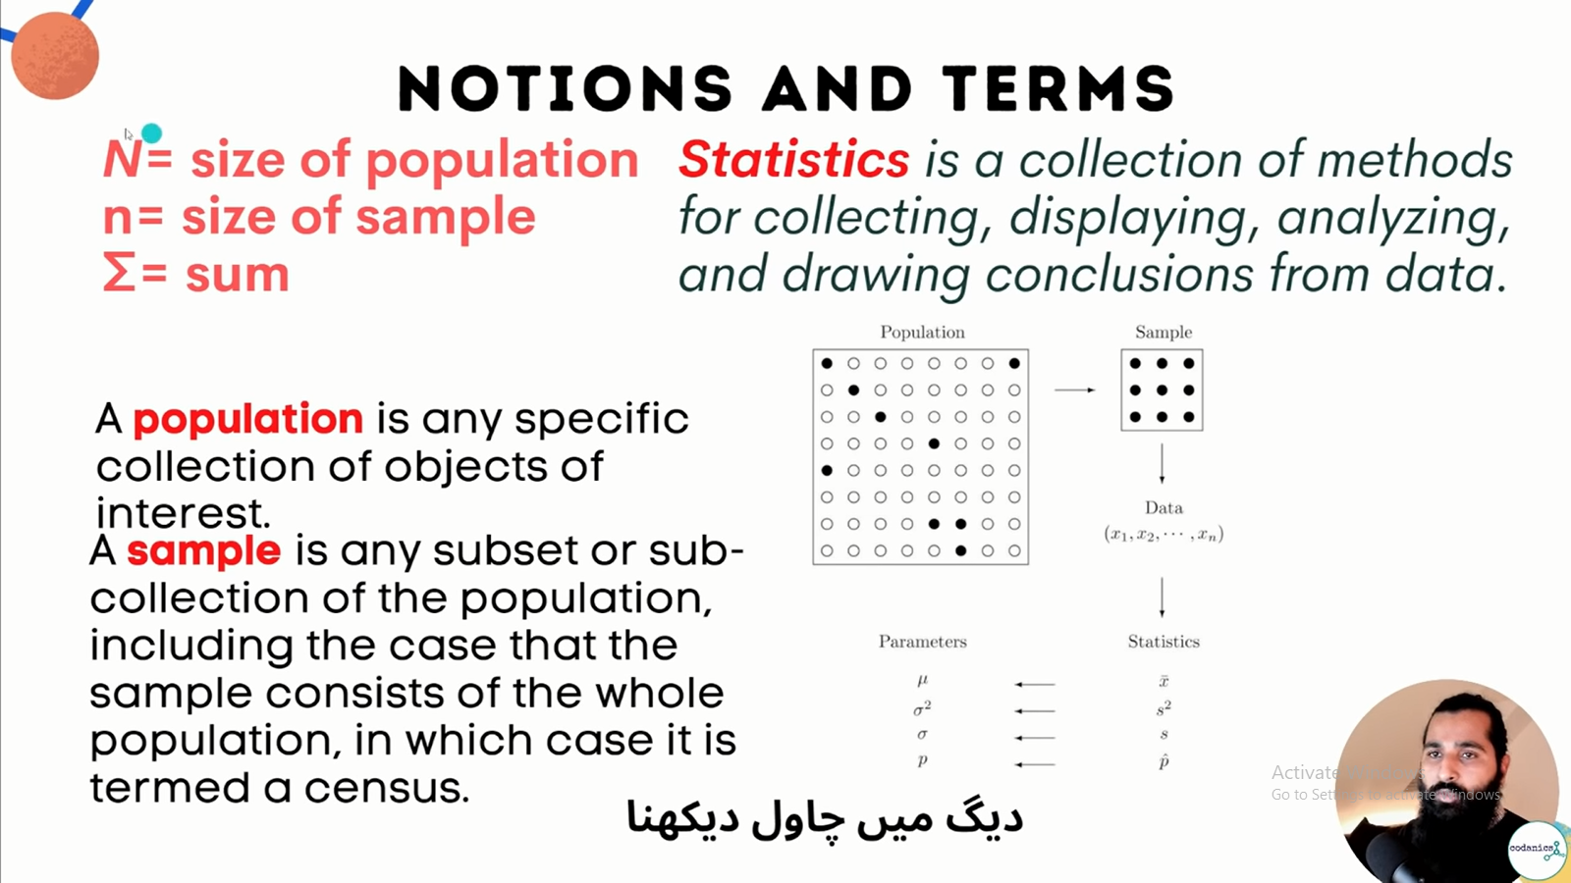

List of Probability and Statistics Symbols

You can explore Probability and Statistics Symbols, name meanings and examples below-

|  |  |  |  |
| --- | --- | --- | --- |
| Symbol | Symbol Name | Meaning / definition | Example |
| P(A ∩ B) | probability of events intersection | probability that of events A and B | P(A∩B) = 0.5 |
| *P*(*A*) | probability function | probability of event A | *P*(*A*) = 0.5 |
| P(A | B) | conditional probability function | probability of event A given event B occurred | P(A | B) = 0.3 |
| P(A ∪ B) | probability of events union | probability that of events A or B | *P*(*A*∪*B*) = 0.5 |
| F(x) | cumulative distribution function (cdf) | F(x) = P(X ≤ x) |  |
| *f*(*x*) | probability density function (pdf) | *P*(*a*≤*x*≤*b*) = *∫ f*(*x*)*dx* |  |
| E(X) | expectation value | expected value of random variable X | E(X) = 10 |
| *μ* | population mean | mean of population values | *μ* = 10 |
| var(X) | variance | variance of random variable X | var(X) = 4 |
| *E*(*X | Y*) | conditional expectation | expected value of random variable X given Y | *E*(*X | Y=2*) = 5 |
| std(X) | standard deviation | standard deviation of random variable X | std(X) = 2 |
| σ*2* | variance | variance of population values | σ*2*= 4 |
| ˜xx~ | median | middle value of random variable x | ˜x=5x~=5< |
| σ*X* | standard deviation | standard deviation value of random variable X | σ*X*= 2 |
| corr(X,Y) | correlation | correlation of random variables X and Y | corr(X,Y) = 0.6 |
| *cov*(*X*,*Y*) | covariance | covariance of random variables X and Y | *cov*(*X,Y*) = 4 |
| *ρX*,*Y* | correlation | correlation of random variables X and Y | *ρX*,*Y* = 0.6 |
| Mo | mode | value that occurs most frequently in population |  |
| Md | sample median | half the population is below this value |  |
| *MR* | mid-range | *MR* = (*xmax*+*xmin*)/2 |  |
| Q2 | median / second quartile | 50% of population are below this value = median of samples |  |
| Q1 | lower / first quartile | 25% of population are below this value |  |
| x | sample mean | average / arithmetic mean | x = (2+5+9) / 3 = 5.333 |
| Q3 | upper / third quartile | 75% of population are below this value |  |
| s | sample standard deviation | population samples standard deviation estimator | s = 2 |
| *s*2 | sample variance | population samples variance estimator | *s*2 = 4 |
| X ~ | distribution of X | distribution of random variable X | X ~ N(0,3) |
| *zx* | standard score | *zx* = (*x*–*x*) /*sx* |  |
| U(a,b) | uniform distribution | equal probability in range a,b | X ~ U(0,3) |
| *N*(*μ*,*σ*2) | normal distribution | gaussian distribution | *X*~*N*(0,3) |
| gamma(c, λ) | gamma distribution | f (x) = λ c xc-1e-λx / Γ(c), x≥0 |  |
| *exp*(λ) | exponential distribution | *f*(*x*)*= λe*–*λx* , *x*≥0 |  |
| F (k1, k2) | F distribution |  |  |
| Bin(n,p) | binomial distribution | f (k) = nCk pk(1-p)n-k |  |
| χ2(*k*) | chi-square distribution | *f*(*x*)*= xk*/2-1*e*–*x*/2 / ( 2k/2Γ(*k*/2) ) |  |
| Geom(p) | geometric distribution | f (k) =  p (1-p) k |  |
| *Poisson*(λ) | Poisson distribution | *f*(*k*)*= λke*–*λ* / *k*! |  |
| Bern(p) | Bernoulli distribution |  |  |
| *HG*(*N*,*K*,*n*) | hypergeometric distribution |  |  |

